Info pack

European voluntary service project
“The(y) Volunteers”

Dates:
- First period: 07.06.2017 - 07.05.2018 -1 volunteer per country: Italy, Poland &Czech republic are preferbale countries and all programe countries without need of visa.
- Second period: 07.02.2018 -07.01.2019-1 volunteer per country: Italy, Poland &Czech republic preferbale countries and all programe countries without need of visa.

Place: Kazanlak, Bulgaria

Hosting organization summary:

“Youth development center-Mutual aid” (YDCMA organization) was founded in 2004. The main idea of organization is to support the development of young people by helping them to develop their physical, creative and spiritual qualities to be good citizens of Republic of Bulgaria

Web site: http://www.ydcma.org
Contact person: Mariya Slavova, e-mail: mslavova@ydcma.org, phone: +359 899 307 090

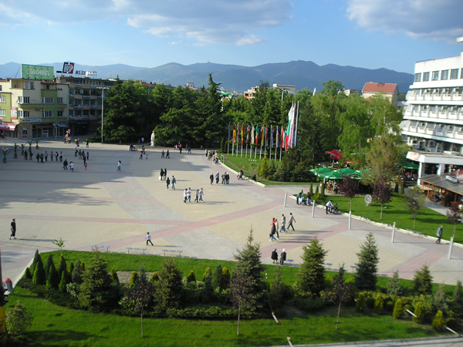
(view of Kazanlak)

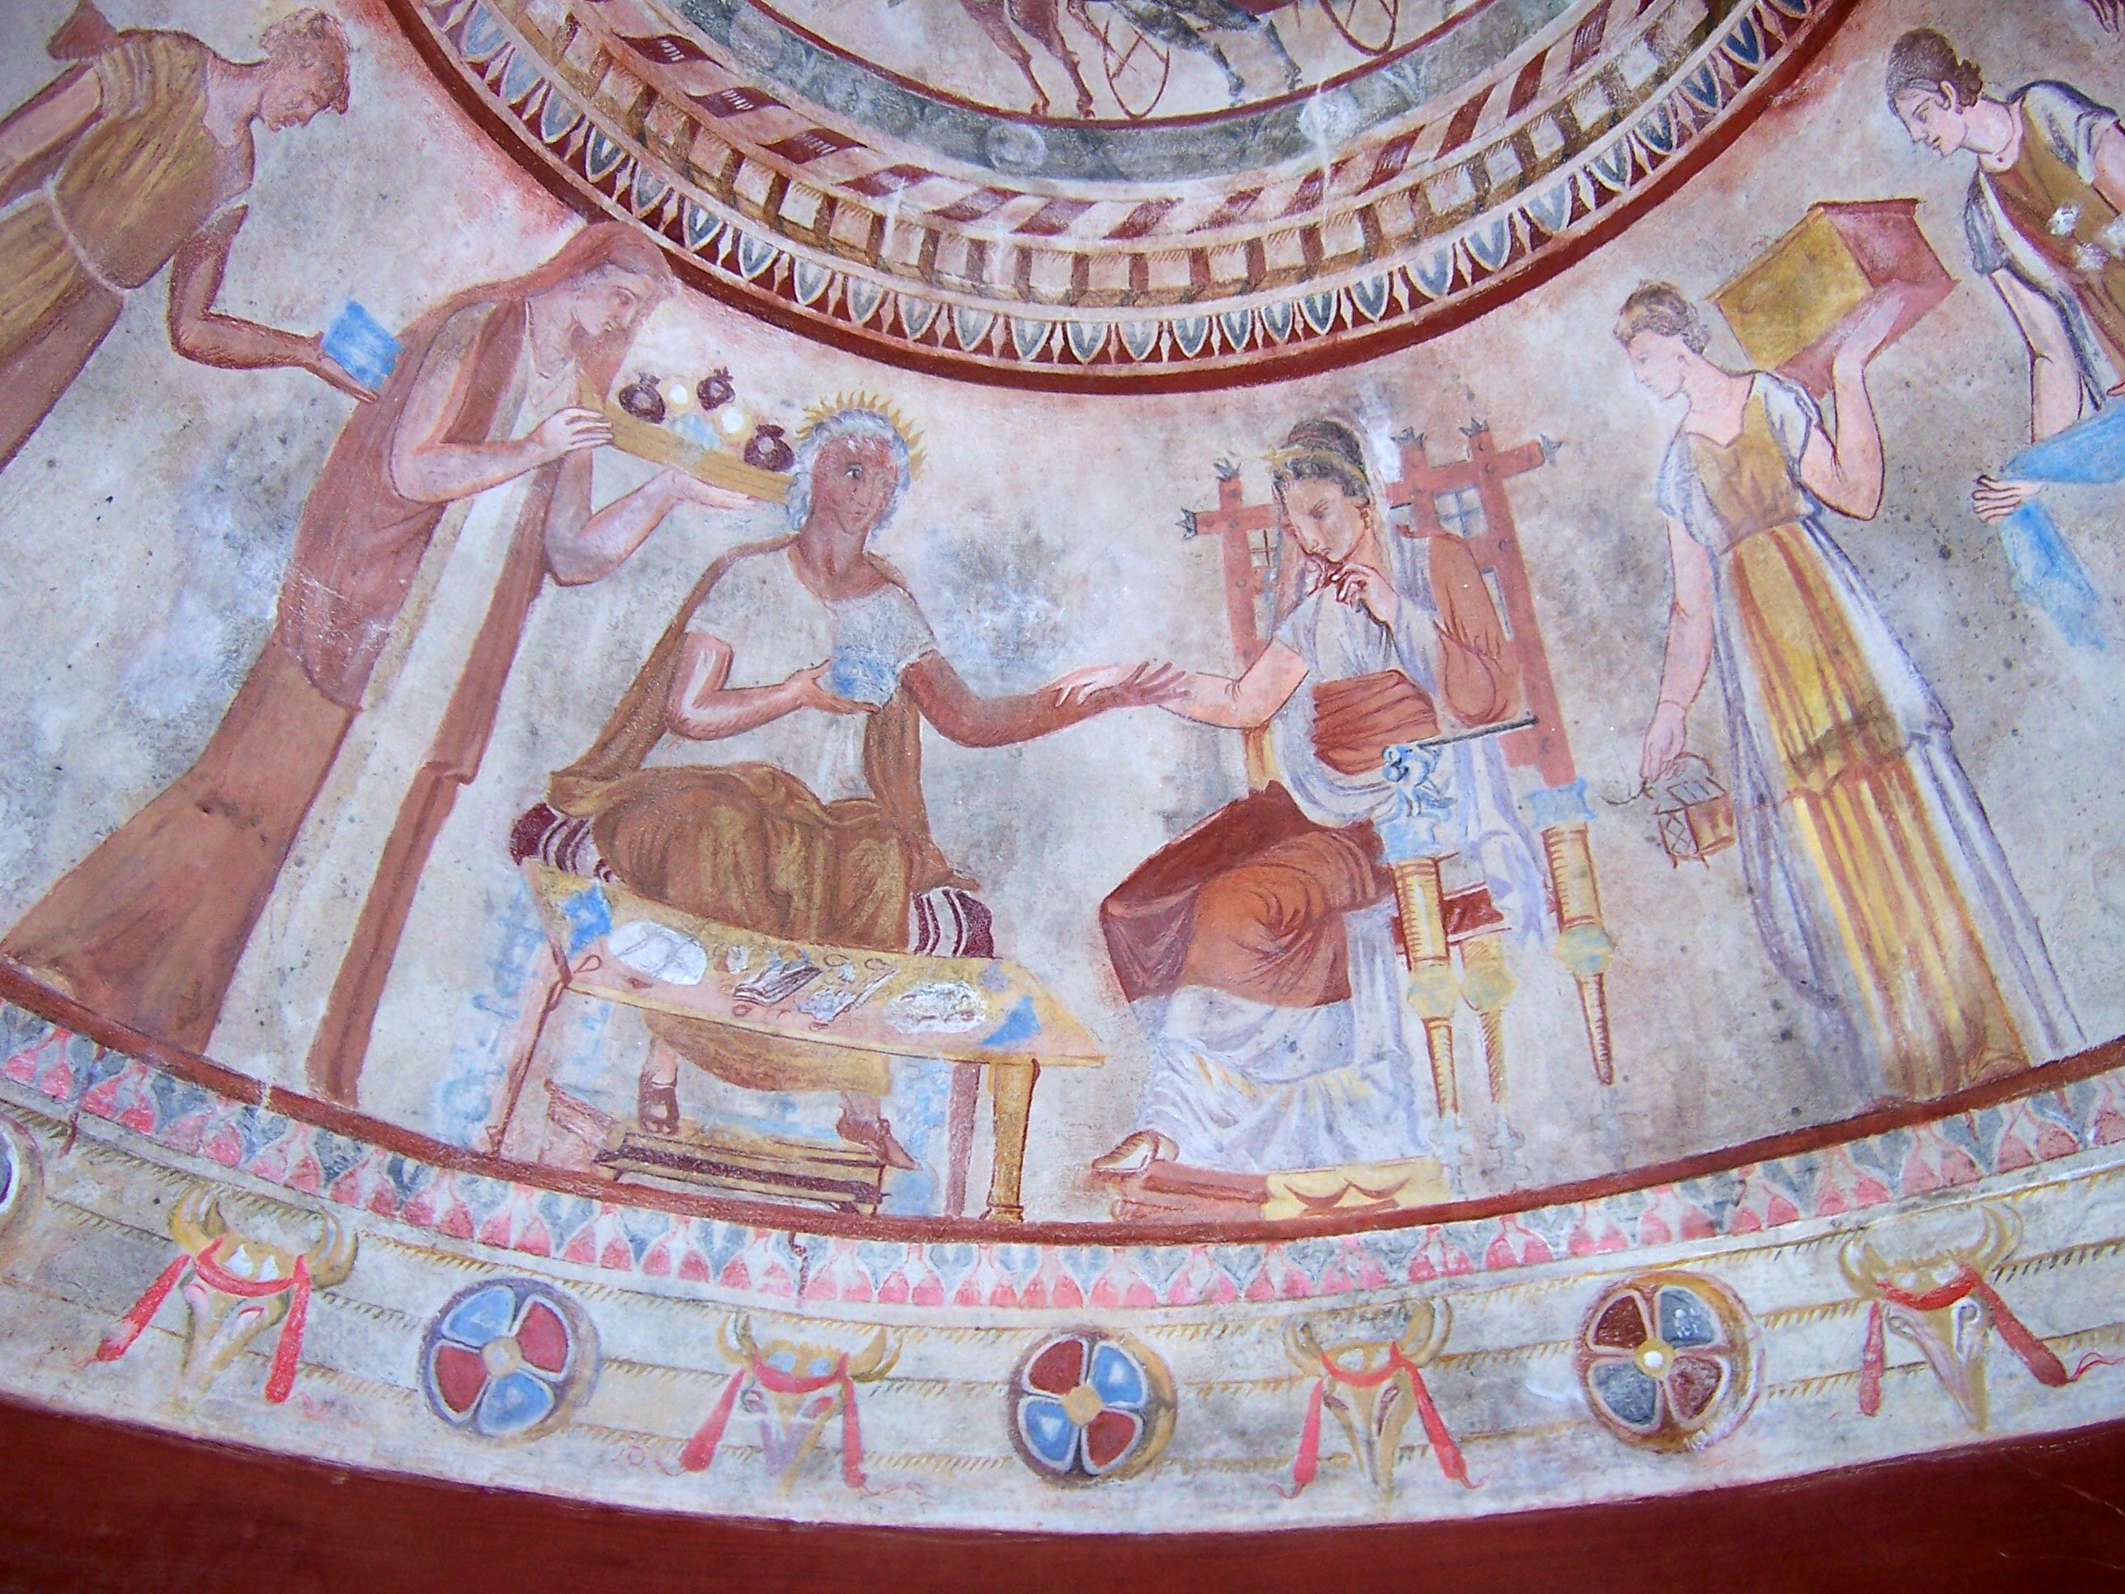

(the Thracian tomb, UNESCO world cultural heritage site)

Project summary:

The project will take place in Kazanlak, Bulgaria- known as the Rose valley. Still, it will include travelling to and activities in other cities- Sofia, Varna, Veliko Tarnovo, and others. It will have two stages of 11 months each: from 07.06.2017 to 07.05.2018; and from 07.02.2018 to 07.01.2019. The total number of volunteers will be 6: 3 volunteers in each stage. The project will improve the volunteers’ skills to do research, to plan, to write and publish, by publishing a newsletter. They will search for news, they will prepare them, analyze them, and will take interviews and take photos in connection with them. The volunteers will do research in the region, will communicate with local people and will cooperate with the members and the interns of the hosting organization. The themes concerned by the project are European citizenship, European awareness and democracy, creativity and art. In the final stage of the project the problem of the youth participation and policies will be also emphasized. We plan the start of a Youtube media channel and a newsletter in printed form.

We search for participants from Poland, Italy, and Czech Republic, who will be able to engage for the whole stage in which they participate. During they stay, they will have the opportunity to do research in the region of Kazanlak, Sofia, other towns in the center of Bulgaria, as well as to get familiar with the local culture in Varna and Veliko Tarnovo. The main stress is put on the social activities and research, which will be conducted in cooperation with our branches and partners in different cities. The volunteers will take part in events of other EVS acreditted organizations. They will produce documentaries and will write articles about these events. The volunteers will also help the hosting organization and its partners to do their daily activities.

Work: the volunteers will take part in various activities together with the person responsible for them : doing research and surveys related to important for youngsters issues, dissemination of brochures and advertisements. They will have the opportunity to carry out their own mini projects related to communication, personal development, active citizenship.

The volunteers will improve their Bulgarian language skills through surveys with the local people. They will take part in organizing various events and will have the opportunity to establish contacts with organizations and business companies from their own country. The working time is 9:00-16:00, with one hour break for lunch. The working time can be changed depending on the activities outside the city. Weekends will be days-off. The other days-off can be planned upon approval of the hosting organization.

Requirements: we search for volunteers interested in social activities and having knowledge in the field of business communication, working with computers, and doing professional photos. The desired applicants are socially active; interested in different cultures; want to become familiar with a different way of living; are open to the world. After preliminary selection, the approved applicants will be interviewed via Skype.

Through this project we will improve our networking with Municipality of Kazanlak, Municipality of Veliko Tarnovo and others, as well as with partners, institutions, local and national NGOs working with EVS. Better contacts with media will be established, and we will develop an electronic media for youth information. The latter will help for the multiplication of the activities.

Main activities are as follow institutions in Kazanlak:
- Daily care center for disabled children and youth;
- Houses for elderly people Nr. 1 and 3;

Location of Kazanlak:

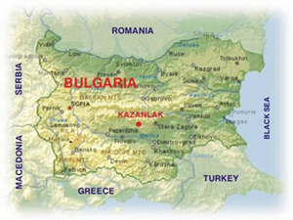

How to reach Kazanlak:

The best way to reach Kazanlak is from Sofia (there is the biggest airport in Bulgaria). From Sofia airport you have to take the metro. The ticket costs 1 lev for a passenger (please take into consideration that passengers with big baggage pay additional ticket for 1 BGN). You have to get off at Central railway station (Централна гара).

Map of Sofia metro:
http://www.metrosofia.com/images/sofia-metro-lines-may-2015.pdf

It is possible to catch a taxi. You should walk a little on the right of the exit of the terminal and you will see plenty of taxis there. The most reliable are “OK taxi”. The price to the railway station might be between 10-12 BGN.

There are two options to get to Kazanlak from there: to take a train (recommended) or bus.

By train:

1. Train to Burgas (Бургас) 7:45 (arrives in Kazanlak at 11:17). Ticket costs 11.40 BGN. For groups between 3 and 6 people the ticket for 1 person costs 9.70 BGN.

2. Train to Burgas (Бургас) 13:00 (arrives in Kazanlak at 16:30). Ticket costs 11:40 BGN. For groups between 3 and 6 people the ticket for 1 person costs 9.70 BGN.

3. Train to Burgas (Бургас) 16:30 (arrives in Kazanlak at 19:40). Express train with mandatory seats reservation. Ticket costs 15.40 BGN. For groups between 3 and 6 people the ticket for 1 person costs 13.30 BGN.

4. Train to Varna (Варна) 22:30 (arrives in Kazanlak at 1:49). Ticket costs 11.40 BGN. For groups between 3 and 6 people the ticket for 1 person costs 9.70 BGN.

We don’t recommend buying tickets on-line because the on-line reservation system is still subjected to tests.

The website of Bulgarian railways:
http://www.bdz.bg/en/

By bus:

The central bus station is located about 50 m from the railway station (warning: there is another small bus station in front of the railway station). You have to search for the ticket desks where they sell tickets to Kazanlak.

10:30 (company: Kumaks/Кумакс). Ticket costs 17 BGN. The duration of the journey is about 3.30 h.

15:00 (the same company)

17:30 (the same company. Instead of a bus, you will travel by a mini bus, so we don’t recommend this hour of departure))

The name of Kazanlak in Bulgarian is written Казанлък. The second “a” is pronounced like “I” in “first”.

The transport is actual till December 2016.

Accommodation:

Organisation will provide a fully equipped private house. Participant will share it with other participants in the activity. Participant will prepare his/her meals on his/her own or together with roommates. Participant is responsible for cleaning his/her clothes and house. Participant is responsible for keeping the living area clean and to take care of the equipment. Participant should keep silence between 23:00 p.m. to 07:00 a.m. It’s important to follow the rules of the house which will be hang up in the house together with contacts of the team.

Pocket money and money for food:

Pocket money in amount of 70 euro per month. The instalment will be paid within the first 7 days of the month.
Money for food in amount of 120 euro per month. The budget of money for food will be given in the middle of the month. Volunteers will have to cook together and buy products for food together, thereby being able to prepare more food for themselves.

Travel expenses:

According to the conditions of the Erasmus + programme, participants in EVS project can have their travel expenses reimbursed within the amount given below. The reimbursement covers your departure from your home town (residence) to the place of activities (Kazanlak). You must depart from the country you represent: for example, if you are a representative of Poland, Italy and Czech republic, you must depart from Poland, Italy and Czech republic.

The reimbursement covers only traveling by plane, train and bus. Money paid for taxi cannot be reimbursed! Please keep all receipts and invoices with you.

Country | Travel expenses covered by the project
Poland | 275
Italy | 275
Czech Republic | 275

Other practical advices:

Insurance: We advice every participant to get a European Health Insurance Card, and to ask the sending organization for more info about the insurance company that Erasmus + programme covered.

Weather: The weather in the beginning of april could be warm. In the past years the temperatures reached 15-20 degrees.

Currency: The currency in Bulgaria is lev (BGN). Its rate to Euro is fixed on 1 Euro = 1.9558 BGN.

Language: Bulgarian is a Slavic language. Young people often speak English, but people like drivers, ticket sellers, shop assistants usually do not speak English, so it is good if you learn some useful phrases in Bulgarian (see below).
The alphabet used in Bulgaria is Cyrillic, so it is recommended also to get some knowledge about it.

Useful phrases in Bulgarian:

Да (da) - yes

Не (ne)- no

Добър ден (dobyr den) – Hello (official)

Добро утро (dobro utro)- Good morning

Лека нощ (leka nosht)- Good night

Здравей/здравейте (zdravey/zdraveyte) – Hello (to 1 person/to more persons)

Довиждане (dovijdane)- Goodbye

Чао (chao)- Bye (informal)

Аз съм от (Az sym ot)- I am from:

-Испания (Ispaniya) Spain
-Полша (Polsha) Poland
-Словения (Sloveniya) Slovenia
-Португалия (Portugaliya) Portugal
-Унгария (Ungariya) Hungary

Извинете (izvinete)- excuse me

Благодаря (blagodarya)- thank you

Моля (molya)- please, you are welcome

Не разбирам (ne razbiram)- I don’t understand

Говоря английски- I speak English

Извинете, къде е автогарата/гарата/тоалетната? (izvinete, kyde e avtogarata/garata/toaletnata)- excuse me, where is the bus station/rail station/toilet?

Влак (vlak)- train
Гара (gara)- railway station

Автобус (avtobus)- bus
Автогара (avtogara)- bus station

Един билет/два билета/три билета/четири билета/пет билета до Казанлък (edin bilet/dva bileta/tri bileta/chetiri bileta/pet bileta do Kazanlak)- One/two/three/four/five tickets to Kazanlak

Колко струва това? (Kolko struva tova)- How much is this?

Търся... (tyrsya)- I am looking for…

Additional phrases: http://wikitravel.org/en/Bulgarian_phrasebook

