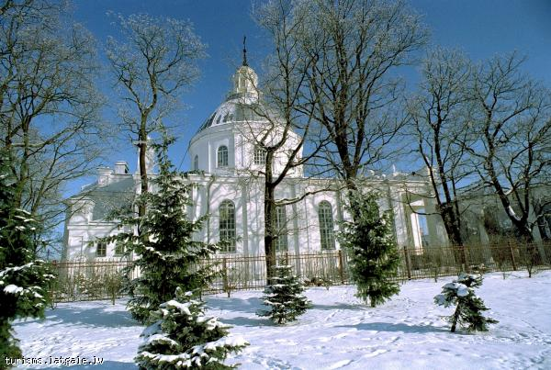
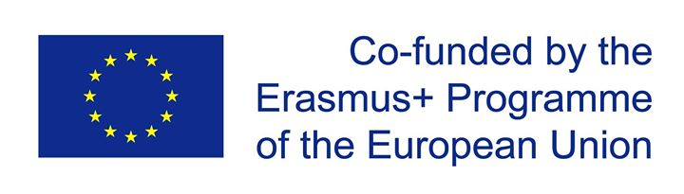
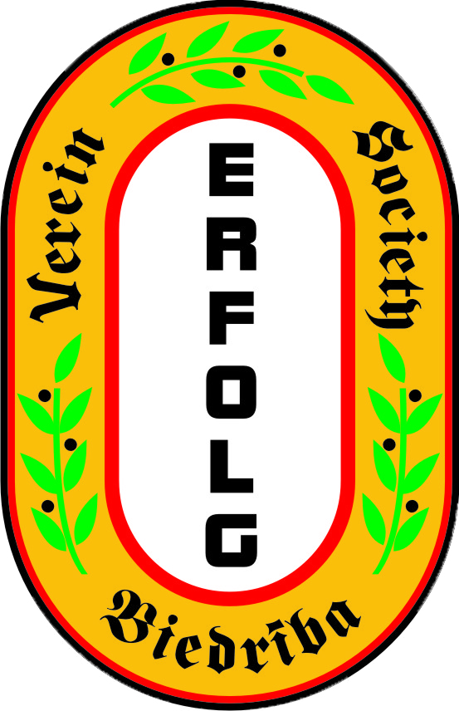

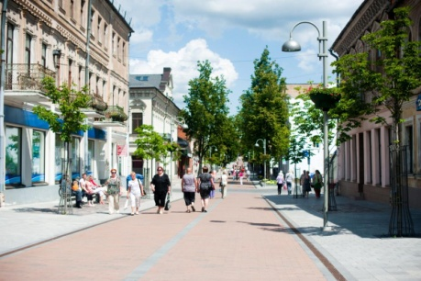

EVS project “Be the change!”

Host organisation:
Society “ERFOLG”
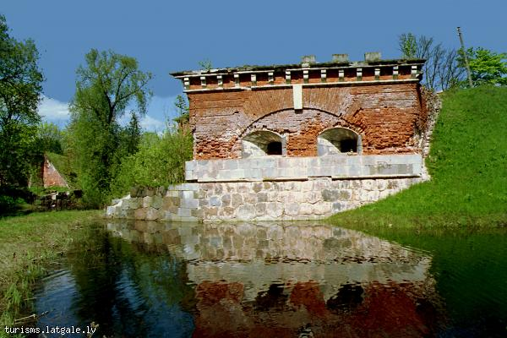
Cietokšņa street 44, Daugavpils, Latvia
E-mail: evs_erfolg@outlook.com
Phone number: +371 20371892/ 65420019
2013-LV-65

Tasks of volunteer:
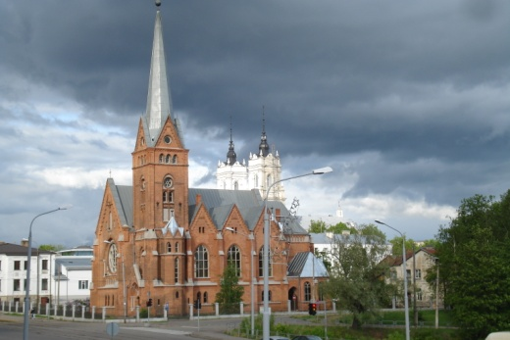
- The volunteer will participate in various youth events, in realization, evaluation and development of the projects and programs;
- Will take part in the organization of the cultural events, concerts and exhibitions;
- Will take part in the organization of the children and youth schools;
- Will participate in the language courses and discussion clubs as a native speaker of the language;
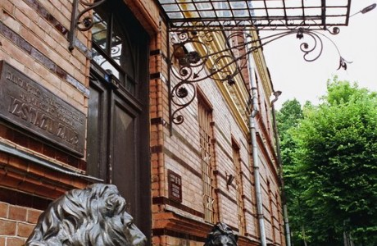
- Will take part in the non-formal education and will use acquired knowledge in practice;
- Will participate in the society’ everyday work realization, for example, to offer his/her own ideas;
- Will consult young people about the European Voluntary Service to create positive attitude towards non-formal education and voluntary service. Will motivate young people to use their free time usefully;
- Will assist in the text translation and correction.
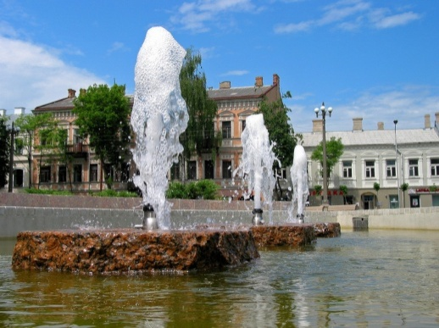
Working hours and days off: The decision about the actual tasks we agree with the volunteers after a 6 week induction phase. That is a work time adaptation period. The weekly working time is 35 hours (including language course time). Leisure time is not always on weekends since the projects main working time is the weekend.
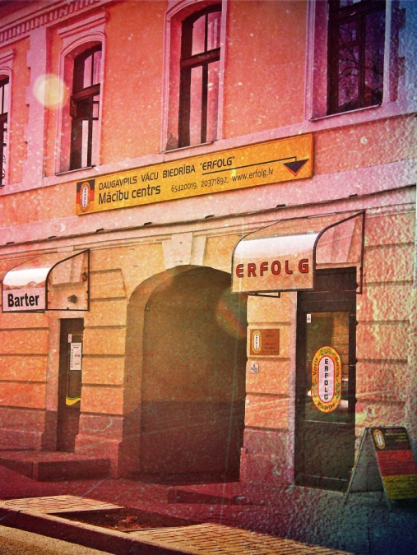
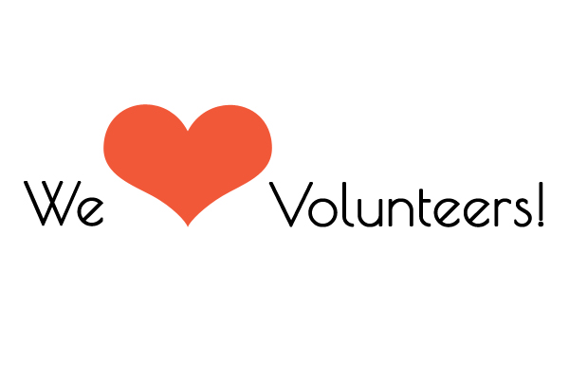
Volunteers’ holiday will be planned together and we mainly consider the wishes of the volunteers. Volunteers get 2 days holiday per month. Overtime will be balanced in accordance with the manager of the project.

