Megaphone 2: Speak Loud, Europe is Listening!
Info-pack

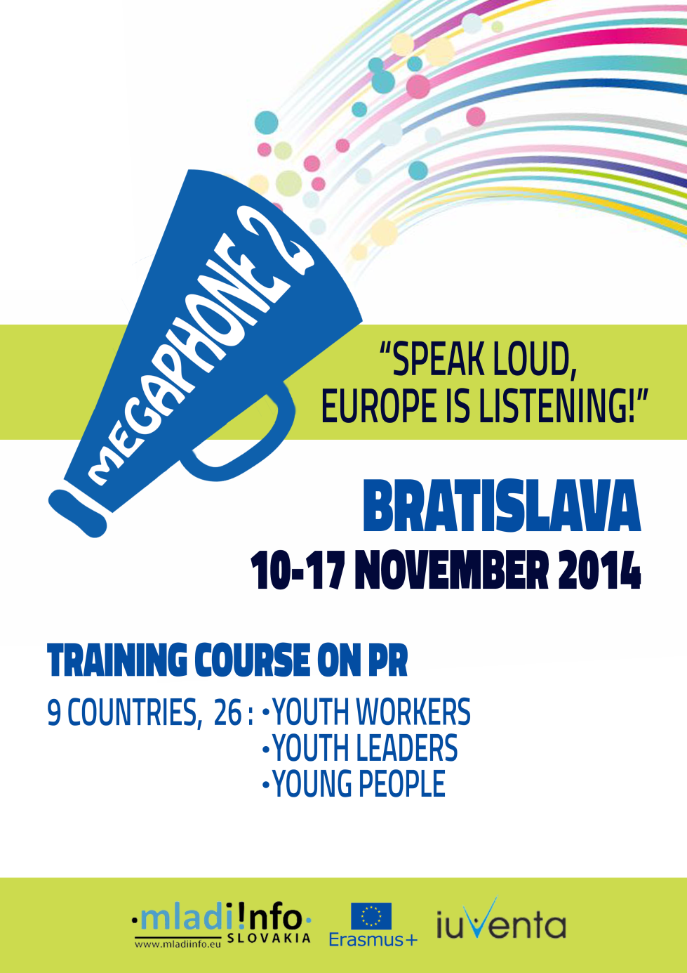

1. Project Description
The Megaphone 2: Speak Loud, Europe is Listening!” training course targets NGOs working along the lines, values and spirit of the Erasmus+ programme and empowers them with relevant competencies and practical tools in the area of public relations, communication with the media and journalists and promotion of their work.
The programme is designed to facilitate the work of the youth organizations in EU and non-EU countries (including the MEDA region) and to achieve the best possible results in its activities. Megaphone 2 comes as follow-up of the successful Megaphone project organized in Macedonia, last year, but now expended to other partner organizations, including the ones from the MEDA region. The fields of training include: communication in cross-cultural environments, building public relations campaigns and actions building strong relations with media and journalists, social media, blogging, web 2.0.
The participants will approach the training presenting their current PR strategies, and during the whole course will learn how to improve them in order to increase the visibility of the work activities of their organization. As a result of the TC they will produce improved, upgraded and tangible PR plans that they should follow after the end of the course.
Topics:
- Youth (Participation, Youth Work, Youth Policy);
- EU Citizenship, EU Awareness and Democracy;
- ICT – New Technologies – Digital Competences.

2. Participating Organizations
Project Applicant: Mladiinfo Slovensko
Mladiinfo Slovensko (www.mladiinfo.sk) was established by former EVS volunteers in 2010 in Bratislava, Slovakia. It is a well-known non-profit organization promoting education and youth mobility. Mladiinfo Slovensko provides young people with information about EU programs, internships, trainings, conferences, volunteering and other opportunities available abroad, but also in Slovakia. Internet is used as the main tool to spread calls, successful stories and motivate youth for participation. Mladiinfo Slovensko office is located in Bratislava-Mlynska dolina, which is the largest complex of student dormitories in Slovakia with almost 10,000 students. It is one of the most active EVS sending organization in Slovakia with more than 50 volunteers being sent for projects in 15 countries. In addition, Mladiinfo Slovensko is a branch of Mladiinfo International – a registered network with the seat in Skopje, a member of EURODESK Slovakia and functions as an info-point of Slovak network of youth information centers.

Partner Organizations:
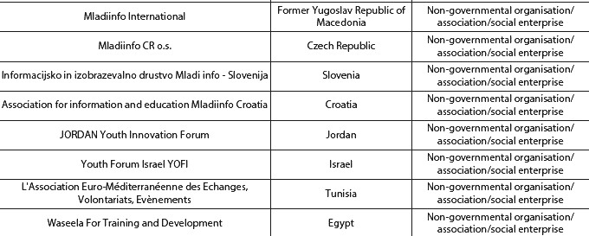

3. Travel Arrangements
All the participants are expected to arrange their travel from their countries to Slovakia and back individually, after consultations with Mladiinfo and their organization. However, the team of Mladiinfo Slovensko, together with participants’ organizations will guide them and help them to plan the journey. The participants are responsible for choosing the cheapest way to reach Bratislava, as well as for booking and buying the travel tickets. Nonetheless, the travel costs will be reimbursed according to the Erasmus + programme rules (see the table).

In order to have the travel expenses reimbursed, one should present:
- Original invoice or bill from the payment of the ticket;
- Boarding passes (in both directions for all connecting and direct flights);
- Mandate form signed and stamped by the organization they present (in original).
Please note that the remuneration could be executed only after the presentation of the full documentation. It is expected to be done immediately after the end of the training course. The reimbursement of the travel expenses higher than 150 euros will be done exclusively through bank transfer.
Following the Erasmus + rules, the travel expenses will be covered according to the distance of the departure place to Bratislava, Slovakia. The table shows the maximum sum to which the travel costs are going to be reimbursed:

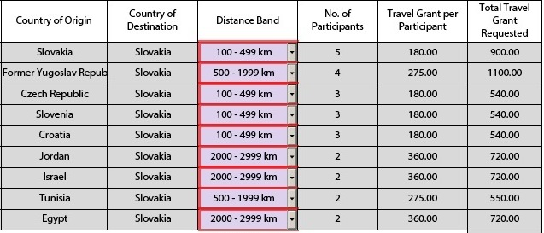

It is very important that as soon as you buy the tickets to inform us about the exact time of your arrival and departure.

4. Accommodation and Venue
Hostel:
All the participants in the training course are going to be accommodated in a hostel in Bratislava, Slovakia in male or female dorm rooms. Please note that the accommodation will be modest, in 4-, 6- or 8-bed dorms, but it will be clean and will provide all the necessary conditions for comfortable stay of group of youngsters. The accommodation will be equipped with wireless internet, shared and/or private bathrooms, kitchen and common area. Some hostels in Bratislava also provide free parking. The precise location of the accommodation will be shared with participants additionally.

Food:
Three meals a day are provided for the training participants. The breakfast is expected to take place in the hostel, whereas the lunch and dinner will be in a venue/restaurant close to the accommodation or the training hall. For the arrival day, a small welcome buffet will be prepared, while for the departure day a breakfast package is foreseen. Please inform the organizer about any special food requirements you might have.
Training room:
The training course will take place in a special, artistic and youth-friendly venue, close to the city centre. The detailed location of the venue will be additionally discussed.

5. Selection of Participants

Megaphone 2 is intended for students, recent graduates or youth who:
- Are above 18 year old;
- Come from one of the participating countries (Slovakia, Macedonia, Slovenia, Tunisia, Czech Republic, Israel, Croatia, Egypt and Jordan);
- Have at least one year experience in youth work;
- Possess basic knowledge about online media and public relations;
- Would like to enhance their knowledge about the Erasmus + programme;
- Have good English skills;
- Plus are communicative, free-spirited and open for new experiences.
Although the organizations are free to choose their representatives, it is expected that a gender balance will be maintained, in order to assure equal number of male and female participants. Please try to nominate equal number of female and male participants, or if you have to nominate odd number of participants, include participants from the two genders. The applicants should be selected based on their motivation and experience, presented in the application form. Once the organization has selected the participants, it should forward their applications to Mladiinfo Slovensko for a final confirmation.

The training course will encompass 26 participants (including the trainer and the support staff) coming from 9 countries, which creates an inspiring international team. The table shows the number of participants per country:
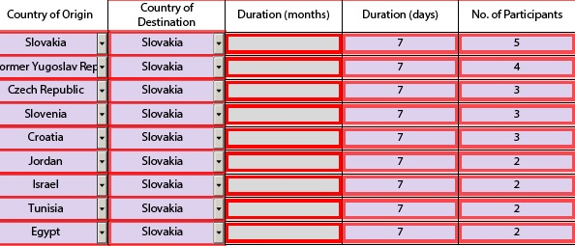

6. Training Preparation
It is expected that the training participants will be actively involved in all the activities and that they will contribute with own ideas and experiences. However, the participants from each organization should:
- Present the current work in the PR field or the media plan of their organization (up to 20 min);
- Prepare one ice-breaker or team-building activity;
- Bring some traditional food or drink from your country for the international evening.

7. Administrative Issues
The participants are obliged to keep and present to Mladiinfo Slovensko all the original invoices and bills regarding their administrative and travel expenses in order to be able to do the reimbursement (according to the project and programme rules). However, the participants requiring a visa to enter Slovakia are encouraged to contact the Embassy of Slovakia in their country (or the regulatory authority of Slovakia in the neighbouring countries) in order to start the visa application. Mladiinfo Slovensko will issue a letter of support for the selected candidates.
Please make sure you have a valid health insurance during your stay in Bratislava. Keep also in mind that in Slovakia it is strictly forbidden to import, carry or consume any kinds of drugs.

8. Useful Information
About Slovakia:
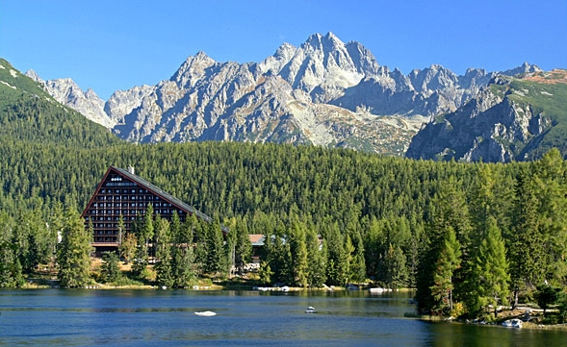
Slovakia has a population of over five million and an area of about 49,000 square kilometres. It is bordered by the Czech Republic and Austria to the west, Poland to the north, Ukraine to the east and Hungary to the south. The largest city is the capital, Bratislava, and the second largest is Košice. Slovakia is a member state of the European Union, Eurozone, Schengen Area, NATO, the United Nations, the OECD and the WTO, among others. The official language is Slovak, a member of the Slavic language family. Long steeped in an agrarian life while being subjects under the Austro-Hungarian Empire, and then after WWII, as comrades within a Soviet satellite state, Slovaks sought to preserve not only their language but also all those distinctive markings of their culture. Among other, Slovaks are particularly proud of their mountains and nature, while hockey is a national sport.
About Bratislava:
Bratislava is the capital of Slovakia with a population of about 500,000. The city is located in south-western Slovakia, occupying both banks of the Danube River and the left bank of the Morava River. Bordering Austria and Hungary, it is the only national capital that borders two independent countries. Known as Pressburg to German-speakers or Pozsony to Hungarian-speakers, Bratislava got its present name only 90 years ago. But the city has a long and proud history that dates back to pre-Roman times. Bratislava's long history - as home to Celts, Romans, Germans, Hungarians, Jews, and of course Slovaks - means there is an impressive range of architecture, languages and cuisine.

The handsome homes of the Austro-Hungarian noble families who built palaces here dot the city, and many of them are now open to the public as museums and galleries. The castle, with its long and chequered history provides great views over the mediaeval old town and the Danube valley from its fortifications. The Danube River itself is, of course, one of the city's main assets. There are several cafes along its banks, within walking distance of the centre. The 'UFO' itself contains an eponymous bar high above the river. The pedestrian decks of the New and Old Bridges are good places to watch the river traffic, including huge Danube barges, glide past. The Austrian capital, Vienna, is only 60 km distant from Bratislava.
How to get here?
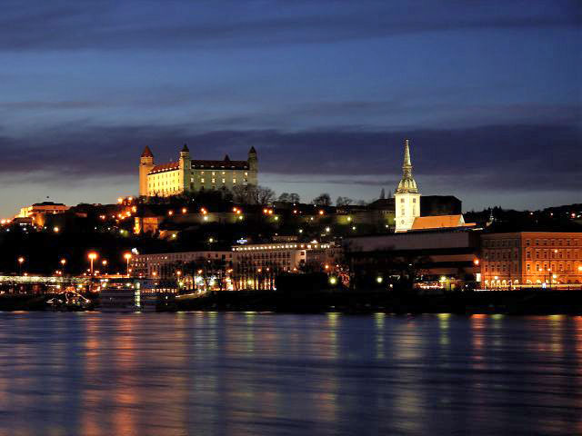

- Bratislava Milan Rastislav Štefánik Airport (Use bus No 61 (or N61 at night) for a direct connection to the terminus Main Railway Station (Hlavná stanica);
- Vienna International Airport / Wien Schwechat (there is a direct bus from Vienna Airport to Bratislava’s city centre - station Novy Most every hour. Check more:
http://www.blaguss.sk/pages/en/timetables.php?lang=EN..and http://www.slovaklines.sk/);
- Bratilslava Central Station (Hlavna Stanica), check the schedule here: http://www.slovakrail.sk/en.html;
- Bratislava Bus Station (well connected by bus to Prague, Budapest, by van to Belgrade).
Public Transport:
Note that the ticket for bus, trolleybus or tram cannot be bought by the drivers, but from the vending machines at the stops. The machines use coins only, 1hour valid transfer ticket costs 0.90 EUR, while 15 minute valid not-transferable ticket costs 0.70 EUR. The tickets should be validated in the marking machines immediately after entering the bus. Find the public transport schedule here: http://imhd.zoznam.sk/.

Taxi:
Taxis are inexpensive, it is much cheaper to call a taxi then to hail a cab on the street. Always make sure the taxi driver use taxi meter, if he refuses, don't get in the taxi. Avoid unofficial taxis which will overcharge you.
Safety:
In general, Bratislava is considered to be a safe city. However, be aware of pickpockets in the public transport and around the central station (Hlavna Stanica).
Currency:
The official currency in Slovakia is Euro. All international credit cards are accepted, however, still paying in cash is preferred.
Practicalities:
As Bratislava is one of the windiest capitals in Europe, the participants should bring a good wind- and water-proof jacket. An umbrella is also a must in November, as well as some water-resistant shoes. You can also take some towel with you, as well as sleepers to use them in the hostel.
Useful numbers and links:
Police 158
Firemen 150
Ambulance (Life emergency) 155
SOS, emergency call 112
FunTaxi: +421216777
Hello Taxi: +421216321
Profi Taxi: +421216222
http://www.bratislava.sk/
http://www.eurodesk.org/edesk/
http://ec.europa.eu/programmes/erasmus-plus/

9. Contact us:
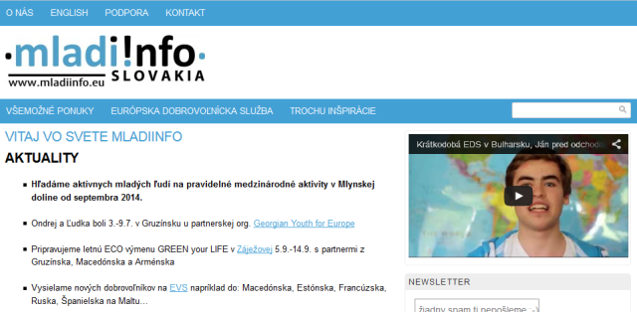

Ana Alibegova
+421 949 470097
ana@mladiinfo.com
Staré Grunty 36
84104 Bratislava

Tatiana Mrugova
+421 944 184 216
evs@mladiinfo.com
Staré Grunty 36
84104 Bratislava

Meet the rest of the crew from our Mladiinfo’s team here: http://www.mladiinfo.sk/kontakt/

